GeminiDecode Web Application Documentation

# Example 1: German Restaurant Receipt

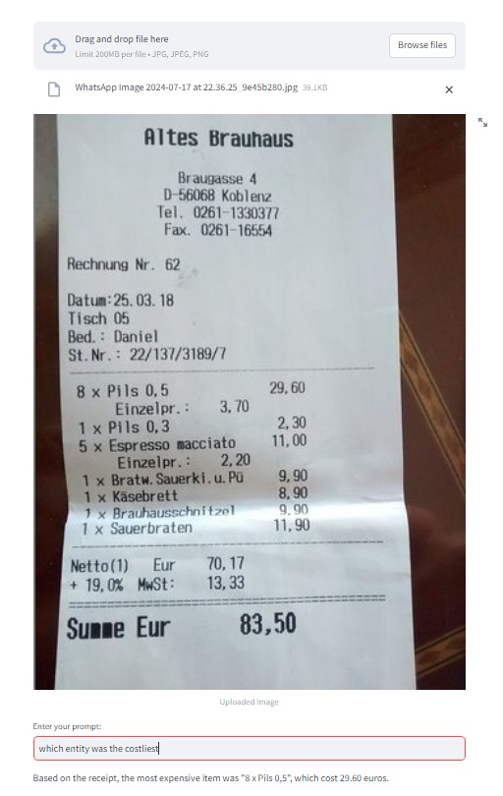

Costliest Entity:

Item: "8 x Pils 0.5"

Cost: €29.60

This example demonstrates the ability of GeminiDecode to handle German-language receipts, extracting relevant information such as itemized costs and identifying the highest cost item. The application can recognize various formats and calculate totals accurately.

# Example 2: French Restaurant Receipt

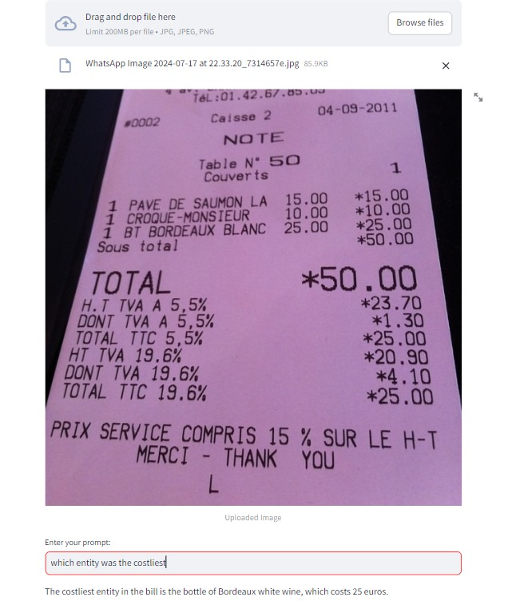

Costliest Entity:

Item: "1 BT Bordeaux Blanc"

Cost: €25.00

In this example, the application processes a French-language receipt. It correctly identifies the most expensive item on the bill, showcasing its multilingual capabilities. This ensures that businesses dealing with international transactions can use GeminiDecode without language barriers.

# Example 3: English Sample Receipt

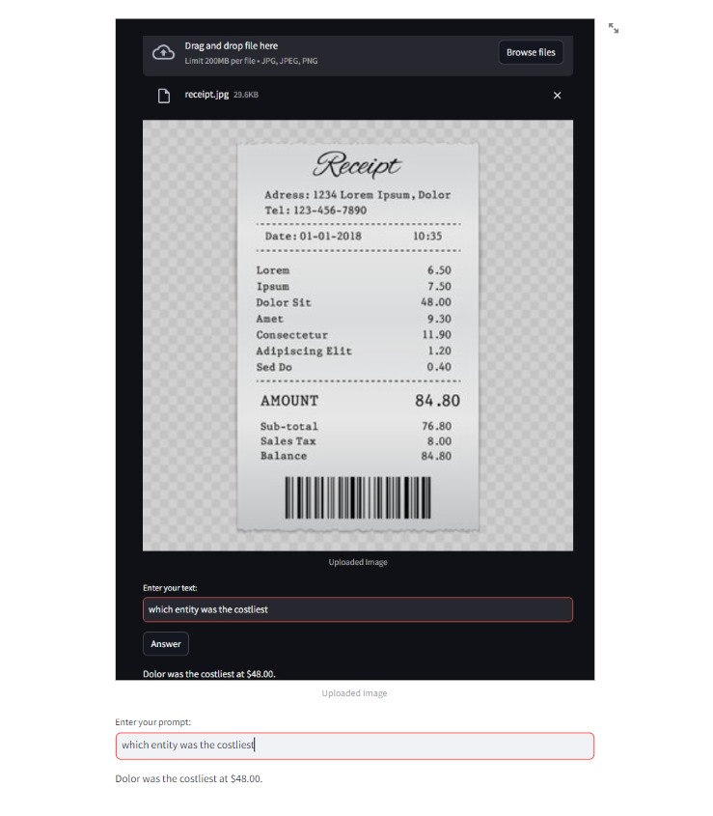

Costliest Entity:

Item: "Dolor Sit"

Cost: $48.00

This example features an English-language sample receipt. GeminiDecode accurately extracts and identifies the highest cost item, emphasizing its proficiency in handling English documents. This example is typical of what users might encounter in various everyday scenarios.

### Example 4: Another English Receipt

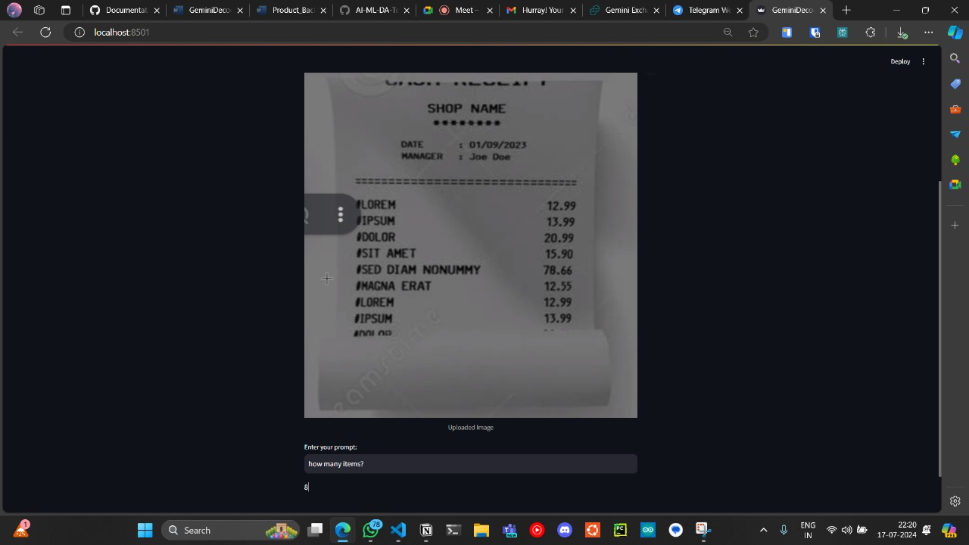

**Image:**

**Costliest Entity:**

* Item: "SED DIAM NONUMMY"
* Cost: $78.66

This example shows another English-language receipt where the application identifies the most expensive item. It further demonstrates the consistent accuracy of GeminiDecode in processing and extracting key information from different receipt formats.

# Problem Statement and Application Overview

## 1. Multilingual Document Processing

GeminiDecode addresses the need to handle documents in multiple languages. Users can upload images of documents written in English, German, French, or other languages. The application leverages Google Gemini Pro Vision API to extract content accurately, regardless of the document's language.

## 2. Efficient Information Extraction

The application is designed to extract specific details efficiently. For instance:  
- Invoices: Extract billing amount, due date, and vendor information.  
- Receipts: Identify costliest items and total amounts.  
- Research Papers: Extract abstracts, author names, and key findings.

## 3. User-Friendly Interface

GeminiDecode offers an intuitive interface allowing users to:  
- Upload images easily.  
- View extracted content in a structured format.  
- Download data for further analysis.

## 4. Scalability and Performance

As the user base grows, GeminiDecode is designed to:  
- Scale seamlessly.  
- Handle multiple requests concurrently without compromising performance.  
- Optimize resource usage to minimize latency.